

Project Design Phase
Solution Architecture

Date | 15 July 2026
Team ID | SWTID-2026-7507
Project Name | DarshanEase - Temple Darshan Ticket Booking App
Maximum Marks | 4 Marks

Solution Architecture Diagram: DarshanEase
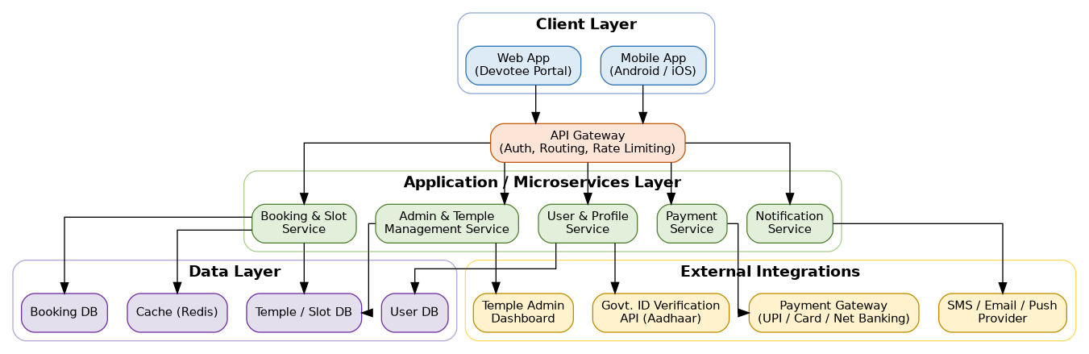
Database Entity-Relationship (ER) Diagram: DarshanEase
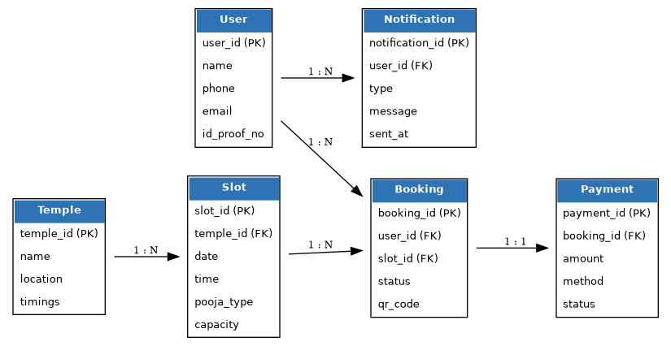
Booking Workflow Diagram: DarshanEase
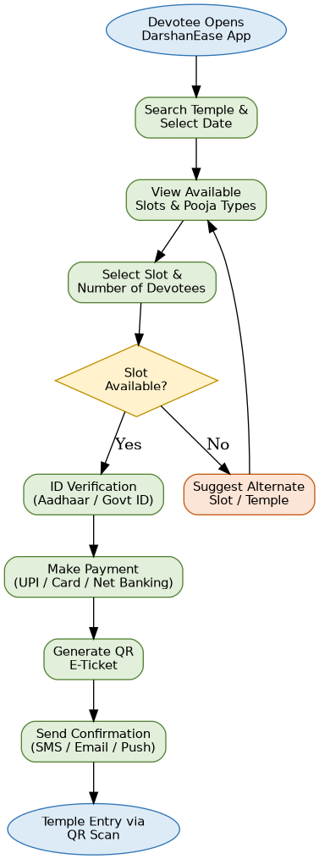
Key UI Screens: DarshanEase
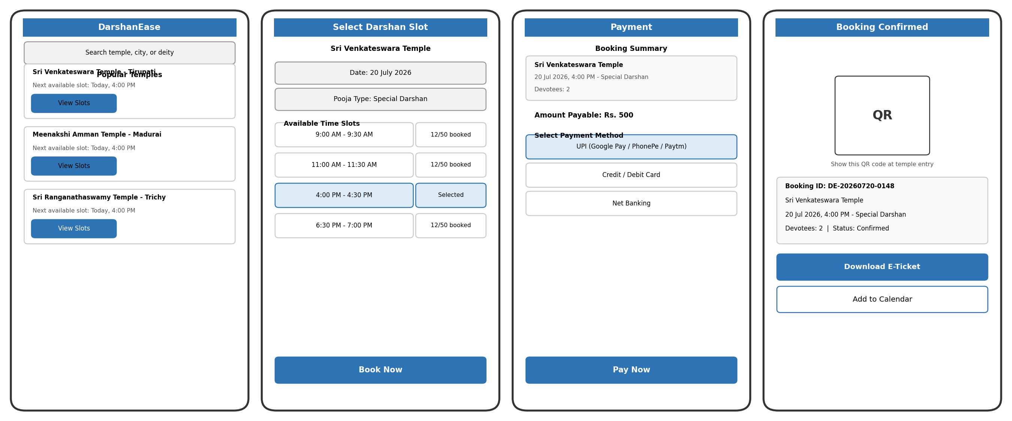
Architecture Components:
Component | Technology / Description
Mobile App | Android & iOS app (Flutter/React Native) for devotees to search, book, and manage darshan slots
Web App | Responsive web portal for booking and temple admin management
API Gateway | Single entry point handling authentication, request routing, and rate limiting
Booking & Slot Service | Manages real-time slot inventory, reservations, and cancellations across temples
User & Profile Service | Handles devotee registration, ID verification, and profile management
Payment Service | Processes booking fees and donations via UPI, cards, and net banking
Notification Service | Sends SMS/email/push alerts for confirmations, reminders, and festival updates
Admin & Temple Management Service | Enables temple staff to configure slots, quotas, and view analytics
Database Layer | Separate stores for user, booking, and temple/slot data, with Redis caching for fast reads
External Integrations | Payment gateway, SMS/push provider, and government ID verification APIs

